**VISVESVARAYA TECHNOLOGICAL UNIVERSITY**

**Jnana Sangama, Belagavi - 590018**

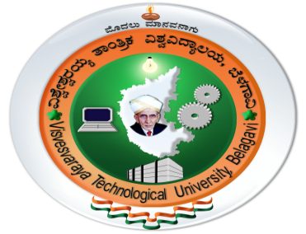

**Mini Project Report**

**on**

**“AUDIO ASSIST FOR THE BLIND”**

***Thesis submitted in partial fulfillment of the requirement for the award of the degree of***

**BACHELOR OF ENGINEERING**

in

**ELECTRONICS AND COMMUNICATION ENGINEERING**

by

|  |  |
| --- | --- |
| **Mr. AKSHAY J RAI** | **4JK19EC006** |
| **Mr. AMAN SASIDHARAN KP** | **4JK19EC008** |
| **Ms. AMRITA SINCHANA** | **4JK19EC009** |
| **Mr. YASHAS SHETTY** | **4JK19EC063** |
|  |  |

**Under the Guidance of**

**Mrs. THRAPTHI SHETTY**

**Assistant Professor**



**DEPARTMENT OF ELECTRONICS AND COMMUNICATION ENGINEERING**

**A J INSTITUTE OF ENGINEERING AND TECHNOLOGY**

**A Unit of Laxmi Memorial Education Trust ®**

**(Approved by AICTE, New Delhi, Affiliated to VTU, Belagavi, Recognized by Govt. of Karnataka)**

**Kottara Chowki, Mangaluru-575006, Karnataka**

**2021-2022**

**A J INSTITUTE OF ENGINEERING AND TECHNOLOGY**

**A Unit of Laxmi Memorial Education Trust ®**

**(Approved by AICTE, New Delhi, Affiliated to VTU, Belagavi, Recognized by Govt.of Karnataka)**

**Kottara Chowki, Mangaluru-575006, Karnataka**

**DEPARTMENT OF ELECTRONICS AND COMMUNICATION ENGINEERING**



**DECLARATION**

We hereby declare that the project report entitled “**AUDIO ASSIST FOR THE BLIND”** which is been submitted to ***A J Institute of Engineering and Technology, Mangaluru*** in partial fulfilment of the requirements for the award of degree of ***Bachelor of Engineering*** in **Electronics and Communication Engineering** is ***a bonafide report of the research work carried out by us.*** The material content in this thesis has not been submitted to any university or institution for the award of any degree.

**Name with USN Signature with Date**

**Mr. AKSHAY J RAI(4JK19EC006)**

**Mr. AMAN SASIDHARAN KP (4JK19EC008)**

**Ms. AMRITA SINCHANA(4JK19EC009)**

**Mr. YASHAS SHETTY(4JK19EC063)**

**Place:**

**Date:**

**A J INSTITUTE OF ENGINEERING AND TECHNOLOGY**

**A Unit of Laxmi Memorial Education Trust ®**

**(Approved by AICTE, New Delhi, Affiliated to VTU, Belagavi, Recognized by Govt.of Karnataka)**

**Kottara Chowki, Mangaluru-575006, Karnataka**

**DEPARTMENT OF ELECTRONICS AND COMMUNICATION ENGINEERING**



**CERTIFICATE**

Certified that the mini project work entitled **“AUDIO ASSIST FOR THE BLIND”** carried out by **Mr. AKSHAY J RAI (4JK19EC006), Mr. AMAN SASIDHARAN KP (4JK19EC008), Ms. AMRITA SINCHANA (4JK19EC009), Mr. YASHAS SHETTY (4JK19EC063),** the bonafide students of **A J Institute of Engineering and Technology** in partial fulfillment for the award of **Bachelor of Engineering** in **Electronics and Communication Engineering** of the **Visvesvaraya Technological University, Belagavi,** during the year **2021-2022.** It is certified that all corrections/suggestions indicated for Internal Assessment have been incorporated in the Report deposited in the departmental library.

The Mini Project, Progress report has been approved as it satisfies the academic requirements in respect of Mini Project Work prescribed for the said Degree.

Signature of the Guide Signature of the HOD Signature of the Principal

**Mrs. Thrapthi Shetty Dr. Gnane Swarnadh Satapathi Dr. Shantharama Rai C**

**External Viva**

**Name of the Examiners Signature with Date**

**1.**

**2**

**ACKNOWLEDGMENTS**

The satisfaction and euphoria that accompany a successful completion of any task would be incomplete without the mention of people who made it possible, success is the epitome of hard work and perseverance, but steadfast of all is encouraging guidance.

So, with gratitude we acknowledge all those whose guidance and encouragement served as beacon of light and crowned the effort with success.

We thank our project guide **Mrs. Thrapthi Shetty**, Assistant Professor, in Department of Electronics & Communication Engineering, who has been our source of inspiration. she has been especially enthusiastic in giving her valuable guidance and critical reviews.

The selection of this project work as well as the timely completion is mainly due to the interest and persuasion of our project coordinator **Dr. Gnane Swarnadh Satapathi**, Associate Professor & Head of the Department of Electronics & Communication Engineering. We will remember his contribution always.

We thank our beloved Principal **Dr. Shantharama Rai C**, for his constant help and support throughout.

We are indebted to **Management of A J Institute of Engineering and Technology, Mangaluru** for providing an environment which helped us in completing our project.

Also, we thank all the teaching and non-teaching staff of Department of Electronics & Communication Engineering for the help rendered.

Finally, we would like to thank our parents whose encouragement and support was invaluable.

**Name Signature with Date**

**Mr. AKSHAY J RAI**

**Mr. AMAN SASIDHARAN KP**

**Mr. AMRITA SINCHANA**

**Mr. YASHAS SHETTY**

**ABSTRACT**

There are about 2.2 billion people with vision impairment or blindness. Visually impaired people face a lot of challenges in their day-to-day life. Physical movement is, in fact, one of the greatest challenges. Blind people find it very difficult to merely walk around high traffic areas or any unfamiliar places and therefore have to take help from other sighted individuals. To move around in familiar places, visually impaired people usually memorize the area and where the things are kept. However, those things if moved to some other place might cause issues for blind people. The most widely used way blind people use to travel from one place to other is the white cane. With all the technological developments, certain devices have been developed to help visually impaired people to move freely around in the environment. This paper presents a systematic literature review for some of the devices developed for navigation purpose of blind people.

**TABLE OF CONTENT**

|  |  |  |  |  |  |  |  |
| --- | --- | --- | --- | --- | --- | --- | --- |
| **CHAPTER NO.** | | **TITLE** | | | **PAGE NO.** |  |  |
|  | | **ACKNOWLEDGEMENT** | | | **i** |  |  |
|  | | **ABSTRACT** | | | **ii** |  |  |
|  | | **TABLE OF CONTENT** | | | **iii-iv** |  |  |
|  | | **LIST OF FIGURES** | | | **v** |  |  |
| **CHAPTER 1** | | **INTRODUCTION** | | | 1-6 |  |  |
|  | | * 1. Introduction   2. Motivation   3. Objectives | | |  |  |  |
|  | | * 1. Methodology   2. Applications   3. Organization of Report | | |  |  |  |
| **CHAPTER 2** | | **LITERATURE REVIEW** | | | 7-10 |  |  |
|  | | 2.1 Literature review | | |  |  |  |
|  | | 2.2 Comparison of blind assistive devices | | |  |  |  |
| **CHAPTER 3** | | **PROBLEM STATEMENT** | | | 11 |  |  |
|  | | 3.1 Problem Statement | | |  |  |  |
| **CHAPTER 4** | | **METHODOLOGY** | | | 12-27 |  |  |
|  | | 4.1 Methodology | | |  |  |  |
|  | | 4.2 Obstacle detection | | |  |  |  |
|  | | 4.3 Object classification | | |  |  |  |
|  | | 4.4 Text to speech | | |  |  |  |
|  | | 4.5 Hardware Requirements  4.6 Software Requirements | | |  |  |  |
|  | |  | | |  |  |  |
|  | | 4.7 Block diagram | | |  |  |  |
| **CHAPTER 5** | | **RESULTS AND DISCUSSION** | | | 28-29 |  |  |
|  | | 5.1 Obstacle detection and Alert Message | | |  |  |  |
|  | | 5.2 Object recognition and Classification | | |  |  |  |
| **CHAPTER 6** | | **CONCLUSION AND FUTURE SCOPE** | | | 30-31 |  |  |
|  | | 6.1 Conclusion | | |  |  |  |
|  | | 6.2 Significance | | |  |  |  |
|  | | 6.3 Future Scope | | |  |  |  |
|  | | 6.4 Applications | | |  |  |  |
|  | | 6.5 Advantages | | |  |  |  |
|  | | **REFERENCES** | | | 32-34 |  |  |
|  | | **APPENDIX A** | | | 35-39 |  |  |
|  | |  | | |  |  |  |
|  |  | |  |
|  | |  | | |  |  |  |
|  |  | |  |
|  | |  | | |  |  |  |

**List of Figures**

|  |  |  |
| --- | --- | --- |
| **FIGURE NO.** | **NAME** | **PAGE NO.** |
| 4.1 | Mode of receiving data from ultrasonic sensor | 13 |
| 4.2 | Top layer of object classification model | 14 |
| 4.3 | In depth layer of object classification model | 15 |
| 4.4 | Text to speech conversion technique | 16 |
| 4.5 | Raspberrypi 4 model-B board | 16 |
| 4.6 | Raspberrypi camera module | 18 |
| 4.7 | Ultrasonic sensor HC-SR04 | 19 |
| 4.8 | Earphone | 20 |
| 4.9 | Layers of deep learning model | 21 |
| 4.10 | TensorFlow logo | 23 |
| 4.11 | OpenCV logo | 24 |
| 4.12 | Screenshot of Raspberrypi OS | 25 |
| 4.13 | Pyttsx3 depiction | 26 |
| 4.14 | Block diagram | 27 |
| 5.1 | Prototype | 28 |
| 5.2 | Prototype with display device | 29 |

**CHAPTER-1**

**INTRODUCTION**

The fast progress of data and organized technology has advanced from the Internet to applying innovations in life which makes our life easier and better in terms of stability and reliability for the betterment of societal needs. One of the technologies to consider is objected acknowledgment innovation, later known as object detection. This term denotes a capacity to identify diverse objects or we use computer vision and image processing to process the two-dimensional quantity, and the device's camera catches their position. The practice of detecting real-world object instances in still photos or videos, such as a car, bike, Television, flowers, and humans or an image without any object, is known as object detection. It lets us recognize, localize, and detect many things inside an image, giving us a better overall understanding of the scene

**1.1 Introduction**

Blind people may lose intention and have a higher risk of falling but people need to move whether at home, at work or addressing meeting. Most of blind people depend on other human for movement and environmental sensitivity. Blind people are suffering from lot of hardships in their daily life. The affected ones have been using the traditional white cane for many years which although being effective still has a lot of disadvantages. Another way is, having a pet animal such as dog, but it is really expensive. So, when a person loses his vision, The impairment is not fixable, even though the employment of glasses, contact lenses or in extreme cases, surgical operation. The incapacity is generally caused by diabetes, macular degeneration, traumatic injuries, infection and eye disease. Alternative causes include blocked blood vessels, complications of premature birth, complication of eye surgery, stroke and tumors. Here square measure several early signs of blindness such a discomfort and weary eyes, foreign body sensation, and pain. Patients could experience discharge from the eyes. World Health Organization has calculable that regarding 285 million individuals worldwide square measure visually impaired; during which 39 million are blind while another 246 million have an occasional vision. The number of people stricken by loss of sight is increasing dramatically. The Royal National Institute of Blind individuals have foretold that by 2020, the amount of visually impaired in UK are going to be over two million people.

Blind individual’s expertise difficulties once travelling to their intended destination. One in every of the larger obstacles is to notice foreign objects across their walking path. With relation to Mau et al., roughly 90th of the blind population is unable to travel alone. 3% of them square measure addicted to their pet whereas the remaining seven-membered uses the white cane. Even with the white cane, their quality is still limited; each indoors and out of doors.

In the twenty first century, the most recent sensible cane to hit the market was introduced by the Indian Technology Delhi’s helpful Technologies group. The device helps the blind people to navigate around an obstacle by measure the distance through vibration detection and measuring device technology. Developers have place in effort to assist the visually impaired feel safe, secure and comfy whenever going enter public or at home. The cane is unceasingly refined to function their second eye that ultimately permits them to steer severally. Smart Cane; developed by Rutgers University and GSET implements inaudible sensors to notice obstacles and a vibrating motor to alert the user. Its construct is comparable to the one developed by Assistance, however with an extra feature which permits the sensing element to be adjusted in step with the peak of the user. Each device but, targeted on obstacles in front of the blind people. Meanwhile, the cane developed by Yoshihiro et al, conjointly considers uneven floor conditions. Dangerous surfaces square measure detected via infrared sensing element and also the information is relayed to the user via earpiece. This project aims to more revolutionize the concept exploitation metal my RIO-1900. The proximity sensing element for obstacle detection will be adjusted to suit user specification. Meantime the output is produced as associate exteroception signal through headphone

Developing accurate Machine Learning Models capable of identifying and localizing multiple objects in a single image has long been a significant challenge in computer vision. However, thanks to recent advances in Deep Learning, developing Object Detection applications is now easier than ever. TensorFlow's Object Detection API is an open-source framework built on top of TensorFlow that makes building, training, and deploying object detection models simple. Detection of objects can be accomplished in a variety of ways. According to the World Health Organization (WHO), over 40 million people worldwide are blind, with another 250 million who have some vision impairment. They face a lot of trouble and constant challenges in Navigation, especially when they are on their own. They need to often depend on someone to get their fundamental daily needs met. So, it is a very challenging task to make a mechanical arrangement for them which is most significant. One of our project's goals is to create an integrated Machine Learning Framework. This will allow visually impaired persons to recognize and classify daily things with voice help. Which in turn calculate distance and issue warnings if the person is too close or too far away from the object. Obstacle detection devices can be built using the same framework

We'll concentrate on Deep Learning Object Detection in this Object Detection project because TensorFlow is based on Deep Learning. Each Object Detection Algorithm works somewhat differently, but they all follow the same basic principles. Feature Extraction: They use their hands to extract features from input images and utilize these features to identify the image's class. MATLAB, OpenCV, Viola-Jones, and Deep Learning are just a few examples. Tensors are multidimensional arrays that extend the functionality of two-dimensional tables to data with a higher dimension. TensorFlow has numerous properties that make it suitable for Deep Learning. So, without spending any time, let's look at how we can use TensorFlow to develop Object Detection. COCO dataset comprises around 330K annotated images for Common Objects in Context. Now you must choose a model because you must make a crucial trade-off between speed and accuracy. The main motto for object detection is to find things, drawing rectangular bounding box-like structures around them with distance. Object detection applications are emerging in numerous diverse areas of counting, recognizing people, checking crops, and real-time applications in sports. Many methods and techniques are introduced to solve the problems of visually impaired people. This paper gives a compelling presentation on object detection and analyzing the gesture of an object using computer vision and machine learning. This paper proposed a well-known computer technology part of image processing and computer vision that focuses on detecting objects in computerized pictures or videos. Face detection, vehicle calculator, and character recognition are just a few of the object detection applications with high criteria. Object detection can be used for a variety of purposes, such as recovery and surveillance. Other essential concepts used in object detection, like using the OpenCV library of python 2.7 progressing in the exactness and effectiveness of object detection, are displayed. This paper described that everyone wants to live independently, especially the disabled ones. Over the past few decades, technology has helped disabled ones control their livelihood. In this study, an assisting system is propped for the blind using YOLO for the object detection within images and video streams based on deep neural networks to make precise detection, and OpenCV under Python using Raspberry Pi3. The result obtained indicates the proposed approach in providing blind users the capability to travel in unfamiliar indoor and outdoor environments through an object identification model and user-friendly device. With the rise of more up-to-date and current developments, the world of innovation has prospered at a rapid rate over the last decade. Our lives have become faster due to the use of more recent advances. The rapid advancement of information and arranged innovation has progressed from the internet and mechanization frameworks, which were initially used for regulatory workplaces and mechanical and commercial applications, to the apparatus of those advances all over life. They began to consider the use of portable gadgets, apps, and versatile systems in natural checking, machine automation, smart home, etc. In order to advance computer vision frameworks, efficient and precise object recognition is essential. The introduction of machine learning and deep learning methods has dramatically increased the precision for object location. The project aims to integrate an Android application for object recognition and localization to achieve high accuracy and real-time performance. The proposed system aims to create a visual aid image processing system for visually impaired people in which the user accepts speech commands. Its functionality addresses the identification of objects and signs. Further, the proposed system will help the visually impaired person manage day-to-day activities and navigate their surroundings. So the aim of the project is to develop a cheap and more efficient way to help visually impaired to navigate with greater comfort, speed and confidence.

**1.2 Motivation**

1. Blind people finding of way through a complex environment

2. The orientation and navigation for these people in unknown environment seems possible

3. Blind peoples are fearless or comfortable about independent mobility or travel

Visually impaired individuals will face many difficulties and one of the common difficulties is when they involve in self-navigating at an environment which is strange for them. In fact, physical movement is one of the biggest challenges for them. Besides that, while they travel around or walking at a crowded corridor, it may pose great difficulty. One of the existing problems for visually impaired individuals to travel in a corridor is that they cannot detect either they need to turn left or turn right when reached to the end of the corridor by using only the walking stick. Example, to walk at the corridor, the visually impaired individuals must find the border of the sidewalk at the corridor and then use their walking stick to define their current location. The reason why the visually impaired individuals do that is because they cannot forecast the obstacle which is far from them while they only can use the walking stick to detect the area around them.

**1.3 Objective**

Audio Assist for Blind navigation wearable system based on live image recognition and ultrasonic obstacles perception used as an audio assistance for blind people. The prototype is enriched with information obtained in real time by other sensors. A map lists these points and indicates the distance and direction between closer points. The blind users wear also glasses built with sensors like The Raspberry Pi Camera Board v2 is a high quality 8-megapixel Sony IMX219 image sensor custom designed add-on board for Raspberry Pi, ultrasonic enhancing the amount and quality of the available information. The user navigates freely in the prepared environment identifying the free path. Based on the origin point information or the location point information and, on the sensor, value the path to next marker (target) is calculated. To raise the perception of the environment, avoiding possible obstacles, it uses ultrasonic sensor. The audio assistance provided to the user makes use of a text to speech converter, with simple known instructions to indicate precisely the desired route and obstacles. progress results showed rates of about 94.92% successful recognition of the obstacles using only 4 frames per second and 98.33% of ultrasonic obstacles perception disposed between 5 meters and 4 meters

**1.4 Methodology**

The project prototype consists of HC-SR04 Ultrasonic Sensor Camera module and a raspberrypi as a central processing unit. To provide the output in the form of audio we are making use of a normal earphone so that the audio message gets successfully delivered to the blind, it has three different stages of operation they are

* Detection
* Processing
* Output

In the detection area Ultrasonic sensor as well as the camera module will be active to send the sensor data to the raspberrypi so that according to the conditions that are satisfied in the algorithm the overall algorithm is built using python. Out of three sections Ultrasonic is the initial section the gives information about the duration. Camera module captures the image and finally raspberry pi is used to process the data and convert it into suitable format for the smooth execution of the device

**1.5 Applications**

Auditory feedback has also increasingly been used in assistive technologies oriented towards the visually impaired. Interestingly, it has been remarked that both the temporal and frequency-based resolution of the auditory sensory system is higher than the resolution of somatosensory receptors along the skin. For several decades, however, this potential advantage of audition over touch was difficult to take advantage of due to limitations in processing power. For instance, given that sound information presented to users is to be synchronized with the frame rate at which new data is read, limitations in visual processing power would have ultimately affected the precision of feedback as well. Even today, frame rates of about 2–6 frames per second (fps) are commonly used, despite the fact that modern camera equipment is easily capable of capturing 5 fps, and that human auditory capabilities would be well suited to interpreting more information.

**1.6 Organization of Report**

**CHAPTER 2**: In this chapter, we discuss the literature review summarizes, analyses, evaluate, and synthesizes the relevant literature within a particular field.

**CHAPTER 3**: In this chapter we discuss about the problem statement that describes the issue that are process improvement project will try to solve. In general, a problem statement will outline the negative points of the current situation and explain why these matters.

**CHAPTER 4**: In this chapter, we discuss the requirements for the project which include hardware components and software setup. We also discuss the methodology of the project.

**CHAPTER 5**: In this chapter, we discuss results and discussions that gives the description of the result which were obtained in the audio assist for the blind

**CHAPTER 6**: This chapter includes conclusion, significance future scope, application and advantages

**CHAPTER-2**

**LITERATURE REVIEW**

A literature review summarizes, analyses, evaluates and synthesizes the relevant literature within a particular field.

**2.1 Literature Review**

[1] Proposed a technique for detecting the obstacles, darkness and to track the visually impaired person. GPS module is used for tracking the user. Camera is used for capturing the images with the help of these images user will come to know what the obstacle is whenever the Infrared Sensor detects the obstacle. Darkness is found out with the help of Light Dependent Resistor. These alerts will be given to the blind through headphones. This device is portable and moreover it works even without connecting to the internet.

[2] This system is specially designed to track the visually impaired person. It facilitates in communicating the panic messages to the respective caretakers along with the current location. This enables the visually impaired person to walk independently through map directions.

[3] Here obstacle detection is done through the ultrasonic sensor which detects the obstacle as well as hole. Water detection is done with the help of moisture sensor. To get back the stick whenever it gets misplaced radio frequency transmission is used. All these modules are controlled by Arduino. It uses GPS for tracking and GSM for sending alert messages in critical conditions.

[4] This approach uses ultrasonic sensor to detect obstacles such as pits, pebbles etc. Water sensor detects the water spreads. Alert is given to the user whenever the detection is found, buzzer starts buzzing when obstacles are detected. Radio frequency transmission is used to find the misplaced stick. GPS tracks the blind person and GSM sends the alert message to the concerned users.

[5] Here haptic feedback is used which supports Bluetooth as well as USB communication. Two separate controllers for USB and Bluetooth communication are used. Computer communication network transmission protocol is used for acknowledgment in order to prevent message drops. It uses Kinect sensor which gives depth data by IR projector which emits different patterns. Kinect sensor detects humans. For example if human weaves his hand it is informed to the user through headphones by which blind comes to know a human is present in front of him.

[6] Multi sensor probe is used in this device which performs task of human detection whenever the user is walking in the crowd. PIR sensor uses infrared radiation to detect the movement of the person. Sonar module provides the target distance and the velocity which helps in calculating the actual distance.

[7] Here obstacle detection is done through ultrasonic sensor and infrared sensor. Buzzer alert is given in different duration for different distances. Buttons are placed for the user navigation. Whenever the button gets pressed the user is informed about the directions from Google maps through voice assistance. Messages are sent to the registered numbers by Bluetooth module with the exact location which is provided by GPS.

[8] Android application which has the ability to detect color, light, object and banknotes. Light detection is done by embedded light sensor and the beep sound is given for different light intensity. Color detection uses RGB values. Bank notes which are detected are identified with previously stored database. These detections are informed through text to speech.

[9] Here, two ultrasonic sensors detect obstacles and moisture sensor is used to find water spreads. User is alerted about the detection with voice output. Data is uploaded to the cloud by using Think speak.

[10] Obstacle detection is done with directions as front, upper and side with the help of ultrasonic sensor. Vibration alert is given to the user when the obstacle is detected. User location is tracked by GPS module.

[11] Robot technique which has video processing module where the video is recorded. Images will be captured from the video and face detection is done with the help of face detection library present in it. Laser sensor detects the depth map and camera is used to detect the obstacles. Decision module guides the robot with the detection output.

[12] Smart glass and walking stick are used. Obstacle detection is done by the smart glass and walking stick reminds the blind about the obstacle. In case of collision, information will be sent to the caretakers through online platform.

[13] Two sensor arrays are used one for receiving and other for transmitting the signal. Receivers will detect the signal of the emitter. This helps in finding the distance range. The device detects the actual target distance. From this, expected distance and actual distance are measured and it is matched.

[14] Obstacle detection is done in three directions namely right, left and front by using ultrasonic sensor. Buzzer will alert the blind when the obstacle gets detected.

[15] Device uses RADAR architecture in order to detect obstacles. It is based on transmitter and receiver sections of the RADAR. The advantage of the device is miniaturization and portability.

[16] Here tutor uses the touchscreen keyboard to teach the blind students where the information will be passed to the microcontroller. Students in the receiver end will receive the data in tactile display. By using this technique multiple blind students can be trained with the help of single tutor.

[17] An application with text to speech technology. The users who want to assist the blind should type the message which will be converted to speech. Blind person will have earphone to hear the voice message.

[20] Based on the construction of the building by determining the direction and the distance of movement, location of blind will be tracked. Data is captured and processed in different stages and a map is generated for the blind to help his navigation. It helps for the indoor navigation of the blind.

[22] It works on echolation and image processing. Images are captured by image sensor. These captured images are used to identify the static and dynamic objects. Ultrasonic sensor detects the obstacle and the distance will be calculated. GPS module helps for the navigation of blind.

[23] It is designed for outdoor navigation. It has buttons to perform different actions. SETUP procedure, navigation, help, emergency and vision system are performed upon pressing the relevant buttons. This prototype is still in initial phase and can be improved better.

[24] Here, blinds were asked to take photographs and the results were quite inaccurate. As per the testing results blind were able shoot videos easily than capturing images. It has the future work where blind can register the images on their own.

[26] They have tested with multi-floor buildings as well as underground passageway. They have estimated and calculated the error between estimated and actual locations. This prototype is helpful for navigation in huge building complexes. [29] Ultrasonic sensor detects obstacle. Level crossing guidance is given through Reflective Infrared Sensor. Wi-Fi module helps to upload current position of data to the cloud. Navigation assistance is given through headphones. Vibration alert is given to the user which helps him in the noisy places where it is difficult to hear.

**2.2 Comparison of Blind Assistive devices**

The ability by which the blind can recognize objects around them solely by hearing is called “obstacle sense.” By analyzing and modeling the mechanism of this sense, the resultant model could be utilized in new concepts for blind mobility aids as well as training methods. We first conducted a comparative experiment regarding coloration perception between the blind and the sighted. In the experiment, subjects are asked to answer whether two successive sounds with a different dip-to-dip interval are perceived to be same by means of two alternative forced choices. The results show no significant difference in discrimination between the two groups; the blind and the sighted. Next, “impressions” elicited by the sounds with various dip-to-dip intervals are analyzed on the two groups using the Semantic Differential Method (SDM). The results indicate that the sighted tend to focus mainly on the quantitatively represented changes such as pitch and loudness of the sounds, while the blind are inclined to focus not only on the quantitative sound change, but also on qualitative impressions in the sound changes. Since it is assumed that the qualitative impressions are related to distances of the obstacles from the blind, third, we carry out a comparative experiment regarding the obstacle-distance perception. The result indicates that the blind can more exactly answer the obstacle-distance than the sighted. From the results of the three experiments and past studies, we discuss whether the obstacle sense is formed in the peripheral process or in the central process of the auditory nervous system, and then we propose new concepts for blind mobility aids as well as the obstacle sense training method.

**CHAPTER-3**

**PROBLEM STATEMENT**

A problem statement is a few sentences that describes the issue that your process improvement project will try to solve. In general, a problem statement will outline the negative points of the current situation and explain why these matters.

**3.1 Problem Statement**

Blind people facing many challenges moving indoor or outdoor. Over 285 million people are visually impaired worldwide: 39 million of them being blind and 246 million have low vision. About 90 percent of the worlds visually impaired live in developing countries. The blind traveler should depend on any other guide like blind cane, people information, trained dogs, and etc. Blind people need some support to feel safe while moving. The survey of the system which is proposed to help those people who are blind or visually impaired.

A university’s campus consists of a vast number of buildings within a wide parameter. There is concern for both new and current students, faculty and staff in navigating around buildings to their destination. This predicament is common for many and is usually resolved through experience, repetition and routine routes. The solution visually impaired individuals have is incomparable because they cannot adapt as well to the environment. Blind individuals struggle when traveling from place to place and rely on predefined and repetitive routes with minimum obstacles to lead them to their destinations without assistance. However, there is a chance that the paths they have grown accustomed to may have new potential hazards or are blocked off due to inclement weather or construction. Therefore, it is important to have navigation devices that allow visually impaired individuals to maneuver and be directed throughout their journey independently and inform them of where their current position may be. Not only is it important for a blind individual to know how to get from one destination to another, it is essential to know what buildings, obstacles, potential hazards and traffic they may be nearby. Majority of them are using a conventional white cane to aid in navigation. The limitation in white cane is that the information’s are gained by touching the objects by the tip of the cane.

**CHAPTER-4**

**METHODOLOGY**

In this chapter, we discuss the requirements for the project which include hardware components and software setup. We also discuss the methodology of the project.

**4.1 Methodology**

Artificial Intelligence, The field of creation of intelligent machines that work like humans and respond quickly, in computer science is known as Artificial intelligence. The core part of AI research is Knowledge engineering. Machines can react and act like humans only when they have abundant information related to the world. To implement knowledge engineering, Artificial intelligence should have access to objects, categories, properties, and relations. To initiate common sense, reasoning and problem-solving power in machines, it is a difficult and tedious task

Convolutional Neural Network (CNN) A convolutional neural network is a class of deep, feedforward artificial neural networks that have successfully been applied to analyze the visual image. CNNs use a multilayer perceptron’s to attain minimal pre-processing. The deep convolutional neural community can gain practical overall performance on challenging visible consciousness tasks, matching or exceeding human performance in some domains. This community that we build is a very small community that can run on a CPU and on GPU properly.

Assistive devices in recent years with the advancement of deep learning and Artificial intelligence has led to its implementation of object and image recognition techniques, where the process of translating and converting images to the form of audio is made possible. In this project, the review of various aspects of Deep learning, Image processing, Artificial intelligence and Machine learning implementation of detection and classifications are covered. This refers to detection and classification of information and communication techniques to deliver sustainable information to the user.

**4.2 Obstacle detection**

Obstacle Detection. To detect obstacles, we are using Ultra Sonic Sensor HC-SR04. Ultrasonic ranging module HC-SR04 provides 2cm to 4m non-contact distance measurement. The HCSR04 module includes ultrasonic receiver, transmitter and control circuit.

The basic principle of working:

* Using I/O, trigger for at least 10µSec high level signal.
* Module automatically sends eight 40kHz pulses and detect whether there is an echo signal back to receiver.
* If the echo signal is back through high level, time of high output I/O duration is the time from sending ultrasonic signal to returning.

For the conversion of duration to distance. Obstacles Distance = (high level time*velocity of sound 340m/S) / 2

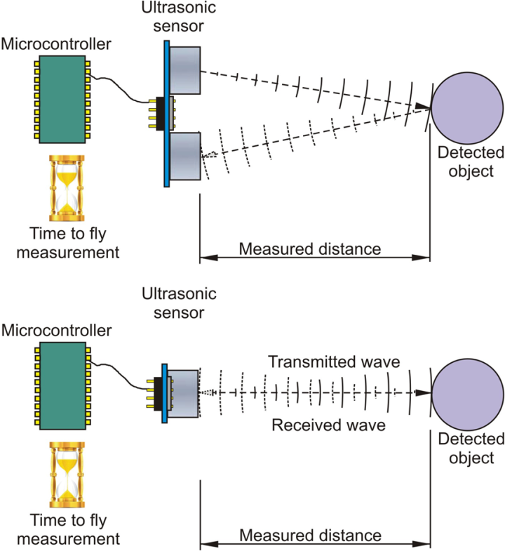

**Figure 4.1: Mode of receiving data from Ultrasonic sensor**

**4.3 Object classification**

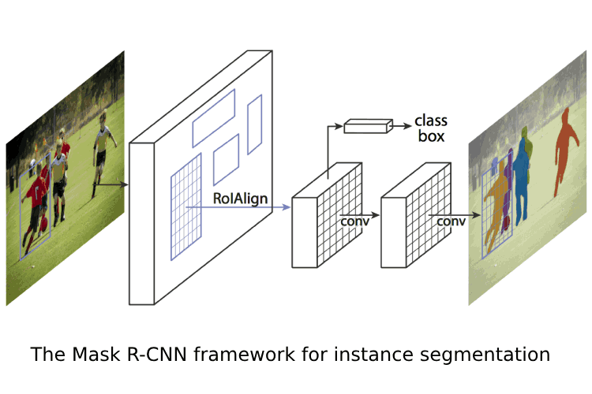Classification identifies objects by classifying them into one of the finite sets of classes, which involves comparing the measured features of a new object with those of a known object or other known criteria and determining whether the new object belongs to a particular category of objects. Using image processing techniques, the images of food products are quantitatively characterized by a set of features, such as size, shape, color, and texture. These features are objective data used to represent the food products, which can be used to form the training set. Once the training set has been obtained, the classification algorithm extracts the knowledge base necessary to make decisions on unknown cases. Based on the knowledge, intelligent decisions are made as outputs and fed back to the knowledge base at the same time, which generalizes the method that inspectors use to accomplish their tasks. The computationally hard part of classification is inducing a classifier-i.e., determining the optimal values of whatever parameters the classifier will use. Classifiers can give simple yes or no answers, and they can also give an estimate of the probability that an object belongs to each of the candidate classes. A number of classification techniques have been introduced including the artificial neural network, Bayesian classification, discriminant analysis, nearest neighbor, fuzzy logic, the decision tree, and the support vector machine. All these methods have shown feasibility for the classification of food products, with various successes. Given the proliferation of classification techniques, it is not an easy task to select an optimal method that can be applied to different food products. It is impossible to offer one technique as a general solution because each classification technique has its own strengths and weaknesses and is suitable for particular kinds of problems.

**Figure 4.2: Top layer of object classification model**

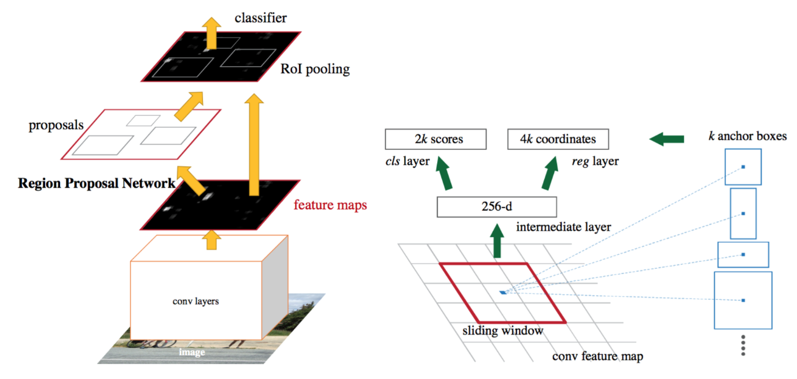

**Figure 4.3: In depth layer of object classification model**

**4.4 Text to speech**

Speech synthesis is the artificial production of human speech. A computer system used for this purpose is called a speech computer or speech synthesizer, and can be implemented in software or hardware products. A text-to-speech (TTS) system converts normal language text into speech; other systems render symbolic linguistic representations like phonetic transcriptions into speech. The reverse process is speech recognition. Synthesized speech can be created by concatenating pieces of recorded speech that are stored in a database. Systems differ in the size of the stored speech units; a system that stores phones or diphones provides the largest output range, but may lack clarity. For specific usage domains, the storage of entire words or sentences allows for high-quality output. Alternatively, a synthesizer can incorporate a model of the vocal tract and other human voice characteristics to create a completely "synthetic" voice output.

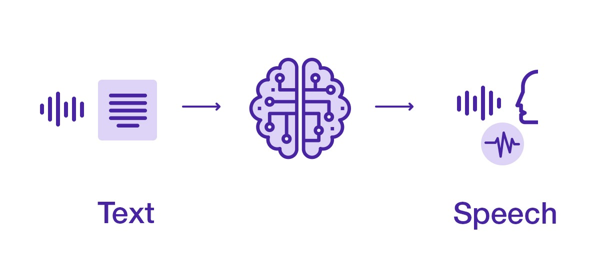

Figure 4.4: text to speech conversion technique

**4.5 Hardware Requirements**

**Raspberry Pi 4**

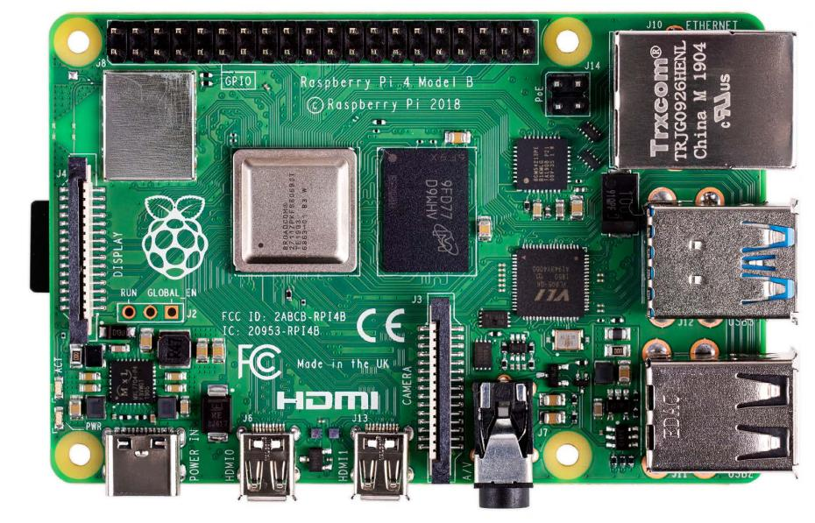The Raspberry Pi is a low cost, **credit-card sized computer** that plugs into a computer monitor or TV, and uses a standard keyboard and mouse. It is a capable little device that enables people of all ages to explore computing, and to learn how to program in languages like Scratch and Python. It’s capable of doing everything you’d expect a desktop computer to do, from browsing the internet and playing high-definition video, to making spreadsheets, word-processing, and playing games.

**Figure 4.5: Raspberrypi 4 model-B board**

Raspberry Pi 4 Model B is the latest product in the popular Raspberry Pi range of computers. It offers ground-breaking increases in processor speed, multimedia performance, memory, and connectivity compared to the prior-generation Raspberry Pi 3 Model B+, while retaining backwards compatibility and similar power consumption. For the end user, Raspberry Pi 4 Model B provides desktop performance comparable to entry-level x86 PC systems. This product’s key features include a high-performance 64bit quad-core processor, dual-display support at resolutions up to 4K via a pair of micro-HDMI ports, hardware video decode at up to 4Kp60, up to 4GB of RAM, dual-band 2.4/5.0 GHz wireless LAN, Bluetooth 5.0, Gigabit Ethernet, USB 3.0, and PoE capability (via a separate PoE HAT add-on). The dual-band wireless LAN and Bluetooth have modular compliance certification, allowing the board to be designed into end products with significantly reduced compliance testing, improving both cost and time to market.

**Technical Specification**

• Broadcom BCM2711, Quad core Cortex-A72 (ARM v8) 64-bit SoC @ 1.5GHz

• 2GB, 4GB or 8GB LPDDR4-3200 SDRAM (depending on model)

• 2.4 GHz and 5.0 GHz IEEE 802.11ac wireless, Bluetooth 5.0, BLE

• 2 USB 3.0 ports; 2 USB 2.0 ports.

• 2 × micro-HDMI ports (up to 4kp60 supported)

• Micro-SD card slot for loading operating system and data storage

• 4-pole stereo audio and composite video port

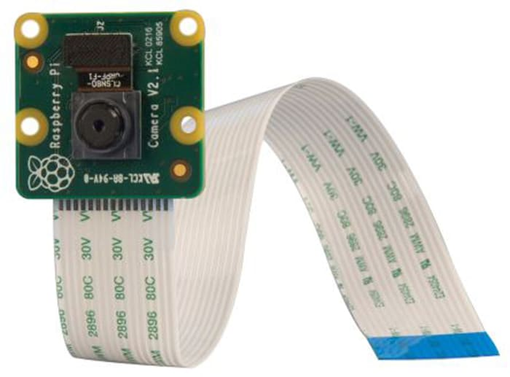**Raspberry Pi Camera Module**

**Figure 4.6: Raspberrypi Camera module**

The Camera Module 2 can be used to take high-definition video, as well as stills photographs. It’s easy to use for beginners, but has plenty to offer advanced users if you’re looking to expand your knowledge. There are lots of examples online of people using it for time-lapse, slow-motion, and other video cleverness. You can also use the libraries we bundle with the camera to create effects.

All models of Raspberry Pi Zero require a Raspberry Pi Zero camera cable; the standard cable supplied with the camera module is not compatible with the Raspberry Pi Zero camera connector.

**Specifications**

* Fixed focus lens on-board
* 8-megapixel native resolution sensor-capable of 3280 x 2464-pixel static images
* Supports 1080p30, 720p60 and 640x480p90 video
* Size 25mm x 23mm x 9mm
* Weight just over 3g
* Connects to the Raspberry Pi board via a short ribbon cable (supplied)
* Camera v2 is supported in the latest version of Raspbian, Raspberry Pi's preferred operating system

**Ultrasonic Sensor**

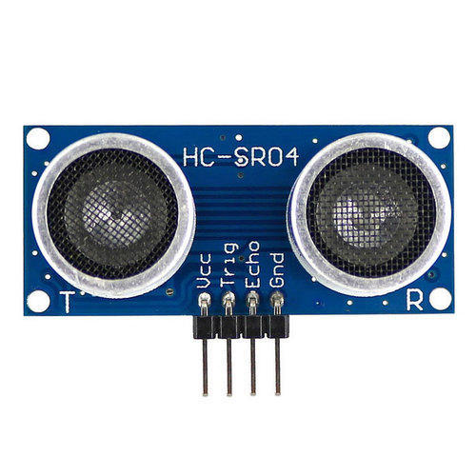An ultrasonic sensor is an electronic device that measures the distance of a target object by emitting ultrasonic sound waves, and converts the reflected sound into an electrical signal. Ultrasonic waves travel faster than the speed of audible sound (i.e., the sound that humans can hear). Ultrasonic sensors have two main components: the transmitter (which emits the sound using piezoelectric crystals) and the receiver (which encounters the sound after it has travelled to and from the target). In order to calculate the distance between the sensor and the object, the sensor measures the time it takes between the emission of the sound by the transmitter to its contact with the receiver. The formula for this calculation is D=1/2T*C (where D is the distance, T is the time, and C is the speed of sound ~ 343 meters/second). For example, if a scientist set up an ultrasonic sensor aimed at a box and it took 0.025 seconds for the sound to bounce back, the distance between the ultrasonic sensor and the box would be: D = 0.5 x 0.025 x 343 or about 4.2875 meters

**Figure 4.7: Ultrasonic sensor HC-SR04**

**Technical specifications:**

* Power Supply: DC 5V
* Working Current: 15mA
* Working Frequency: 40Hz
* Ranging Distance: 2cm – 400cm/4m

**Earphones**

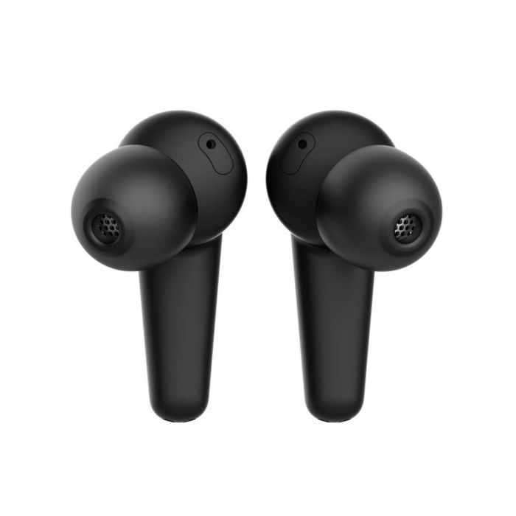

**Figure 4.8: Earphone**

Earphones are a pair of small loudspeaker drivers worn on or around the head over a user's ears. They are electroacoustic transducers, which convert an electrical signal to a corresponding sound. Headphones let a single user listen to an audio source privately, in contrast to a loudspeaker, which emits sound into the open air for anyone nearby to hear. Headphones are also known as ear speakers, earphones or, colloquially, cans. Circumoral ('around the ear') and supra-aural ('over the ear') headphones use a band over the top of the head to hold the speakers in place. Another type, known as earbuds or earpieces consist of individual units that plug into the user's ear canal.

**4.6 Software Requirements**

**Deep Learning**

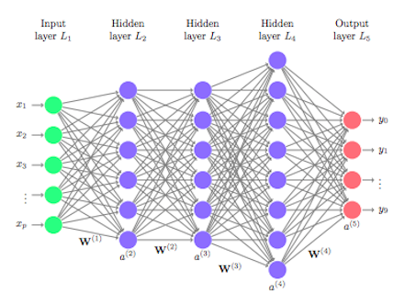Deep learning is a type of machine learning and artificial intelligence (AI) that imitates the way humans gain certain types of knowledge. Deep learning is an important element of data science,

**Figure 4.9: layers of deep learning model**

which includes statistics and predictive modelling. It is extremely beneficial to data scientists who are tasked with collecting, analyzing and interpreting large amounts of data; deep learning makes this process faster and easier.

At its simplest, deep learning can be thought of as a way to automate predictive analytics. While traditional machine learning algorithms are linear, deep learning algorithms are stacked in a hierarchy of increasing complexity and abstraction.

To understand deep learning, imagine a toddler whose first word is dog. The toddler learns what a dog is -- and is not -- by pointing to objects and saying the word dog. The parent says, "Yes, that is a dog," or, "No, that is not a dog." As the toddler continues to point to objects, he becomes more aware of the features that all dogs possess. What the toddler does, without knowing it, is clarify a complex abstraction -- the concept of dog -- by building a hierarchy in which each level of abstraction is created with knowledge that was gained from the preceding layer of the hierarchy.

**TensorFlow**

TensorFlow is a Python-friendly open source library for numerical computation that makes machine learning and developing neural networks faster and easier.

Machine learning is a complex discipline but implementing machine learning models is far less daunting than it used to be, thanks to machine learning frameworks—such as Google’s TensorFlow—that ease the process of acquiring data, training models, serving predictions, and refining future results.

Created by the Google Brain team and initially released to the public in 2015, TensorFlow is an open-source library for numerical computation and large-scale machine learning. TensorFlow bundles together a slew of machine learning and deep learning models and algorithms (aka neural networks) and makes them useful by way of common programmatic metaphors. It uses Python or JavaScript to provide a convenient front-end API for building applications, while executing those applications in high-performance C++.

TensorFlow provides all of this for the programmer by way of the Python language. Python is easy to learn and work with, and it provides convenient ways to express how high-level abstractions can be coupled together. TensorFlow is supported on Python versions 3.7 through 3.10, and while it may work on earlier versions of Python it's not guaranteed to do so.

Nodes and tensors in TensorFlow are Python objects, and TensorFlow applications are themselves Python applications. The actual math operations, however, are not performed in Python. The libraries of transformations that are available through TensorFlow are written as high-performance C++ binaries. Python just directs traffic between the pieces and provides high-level programming abstractions to hook them together.

High-level work in TensorFlow—creating nodes and layers and linking them together—uses the Keras library. The Keras API is outwardly simple; a basic model with three layers can be defined in less than 10 lines of code, and the training code for the same takes just a few more lines of code. But if you want to "lift the hood" and do more fine-grained work, such as writing your own training loop, you can do that.



**Figure 4.10: TensorFlow logo**

**Open CV**

OpenCV is a cross-platform library using which we can develop real-time computer vision applications. It mainly focuses on image processing, video capture and analysis including features like face detection and object detection.

Computer Vision can be defined as a discipline that explains how to reconstruct, interrupt, and understand a 3D scene from its 2D images, in terms of the properties of the structure present in the scene. It deals with modeling and replicating human vision using computer software and hardware.

Computer Vision overlaps significantly with the following fields −

• Image Processing − It focuses on image manipulation.

• Pattern Recognition − It explains various techniques to classify patterns.

• Photogrammetry − It is concerned with obtaining accurate measurements from images.



**Figure 4.11: OpenCV logo**

Features of OpenCV Library

Using OpenCV library, you can −

• Read and write images

• Capture and save videos

• Process images (filter, transform)

• Perform feature detection

• Detect specific objects such as faces, eyes, cars, in the videos or images.

• Analyze the video, i.e., estimate the motion in it, subtract the background, and track objects in it.

**Raspberrypi OS**

Raspberry Pi OS is a free, open-source Debian Linux-based operating system engineered for use on Pi boards. Additionally, several ARM-based single-board computers also run Raspberry Pi OS. The first version, then known as Raspbian, debuted in 2013, and from 2015 onwards the Raspberry Pi Foundation offered it as an officially-sanctioned Pi distro. Developers Peter Green and Mike Thompson are responsible for creating Raspbian, initially an independent endeavor.

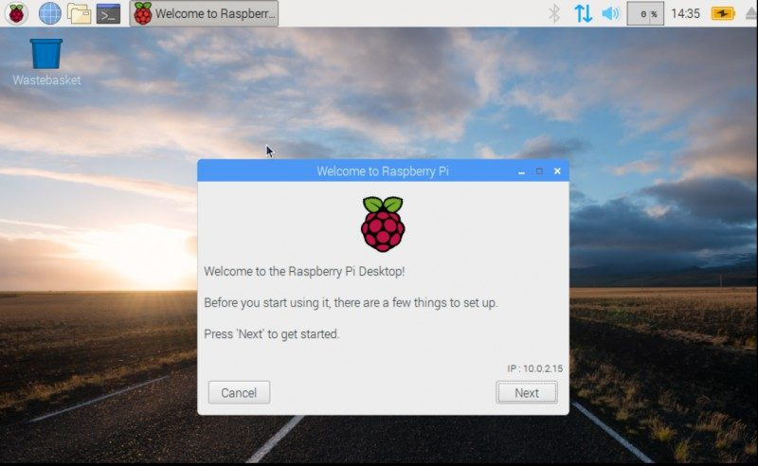

**Figure 4.12: Screenshot of Raspberrian OS**

Raspberry Pi OS is an excellent option for general desktop use. The 64-bit version when mated to an 8GB Pi board or even 4GB Pi should showcase the credit card-sized maker board's potential for multi-tasking and general computing capabilities. Since it's Linux-based, Raspberry Pi OS can easily be customized for individual use cases. You can install media server software such as Plex, Emby, or Subsonic for a Raspberry Pi NAS. Or load up the likes of Kodi and VLC for a home theatre PC (HTPC). It's great for office productivity including image or audio editing and programming.

And gaming is a blast. You'll find many games that run natively on the Raspberry Pi, or you can install emulators such as RetroArch. Overall, Raspberry Pi OS is arguably the best distro for most Pi users. It's a versatile OS that's guaranteed to be polished and benefit from continued development. A few different options are available, including a desktop variant with recommended software, a barebones desktop image, and a minimal command-line only option. You might also consider Ubuntu which offers both 32-bit and 64-bit Raspberry Pi images.

**Pyttsx3**

pyttsx3 is a text-to-speech conversion library in Python. Unlike alternative libraries, it works offline and is compatible with both Python 2 and 3. An application invokes the pyttsx3.init() factory function to get a reference to a pyttsx3. Engine instance. it is a very easy to use tool which converts the entered text into speech. The pyttsx3 module supports two voices first is female and the second is male which is provided by “sapi5” for windows. It supports three TTS engines:

• sapi5 – SAPI5 on Windows

• nsss – NSSpeechSynthesizer on Mac OS X

• espeak – eSpeak on every other platform

**Figure 4.13: pytsx3 depiction**

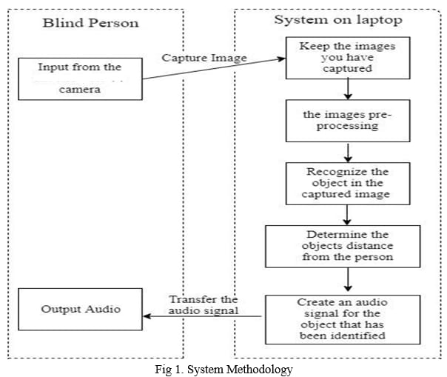**4.7 Block diagram**

**Raspberry pi**

**Ultrasonic Sensor**

**Figure 4.14: block diagram**

Initially the device captures the samples for processing and then it performs the detection to classify the objects which will recognize based on the classes that are trained. To check the distance between the object. Raspberrypi sends instruction to activate the ultrasonic sensor to fetch the data for measuring the distance between the obstacle that detected finally the message will be outputted through an earphone

**CHAPTER 5**

**RESULTS AND DISCUSSION**

In this chapter, we discuss results and discussions that gives the description of the result which were obtained in the audio assist for the blind

**5.1 Obstacle detection and Alert Message**

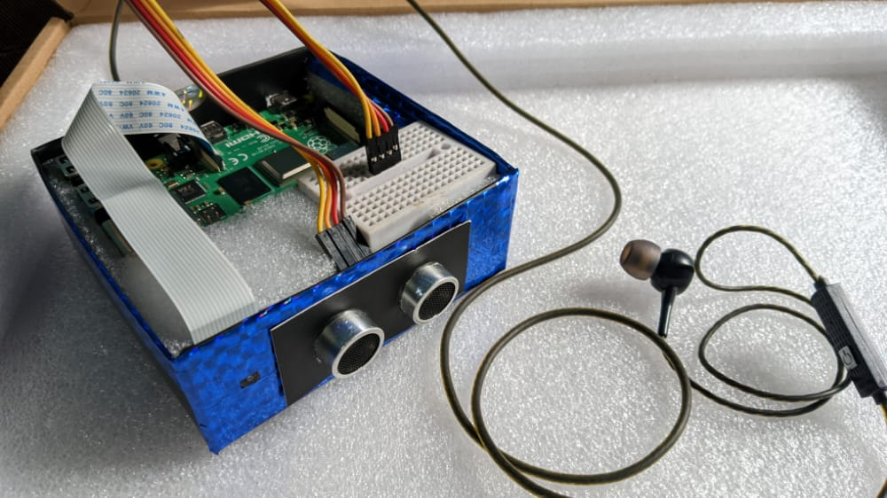The model can now detect obstacles in front of it and it can also give alert message in the form of audio through the earphone

**Figure 5.1: Prototype**

**5.2 Object recognition and Classification**

The algorithm now can detect and recognize the object in an image and labels it accordingly. When connected to a display device it can display the label of the recognized object.

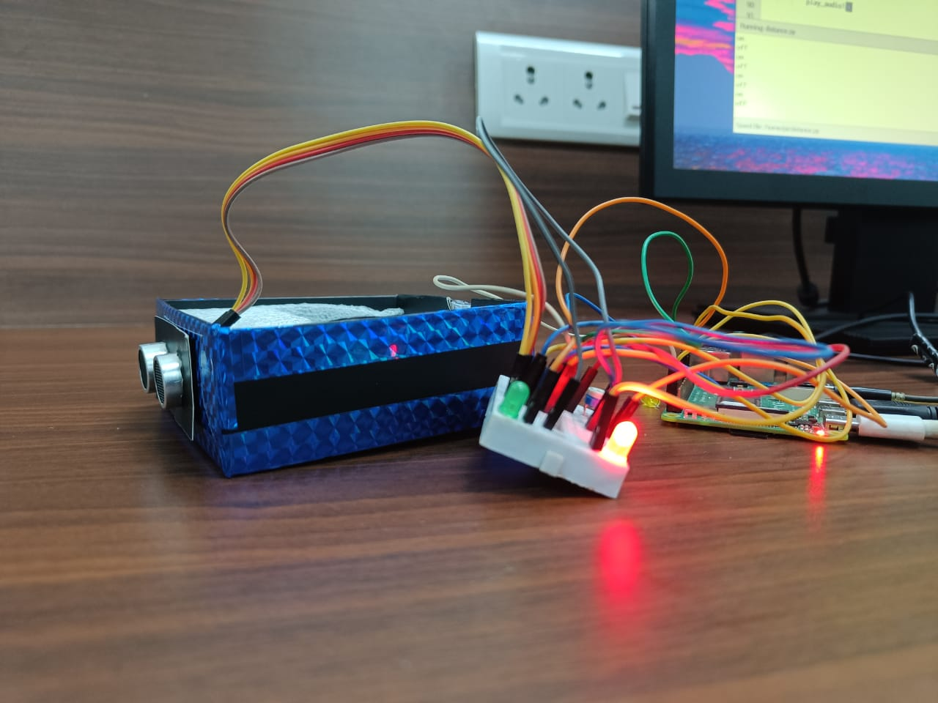

**Figure 5.2: prototype with display device**

**CHAPTER 6**

**CONCLUSION AND FUTURE SCOPE**

This chapter includes conclusion, significance future scope, application and advantages

**6.1 Conclusion**

We have surveyed the systems which are designed to assist the visually impaired person. This report gives an overall view of the prototypes which have been implemented and yet to implement. Survey of all the assistive devices which helps the visually impaired person has been done. It consists of problems which the visually impaired people are facing in their day-to-day life and solution to these problems has been given. Based on the survey the systems are advanced to help the blind in various fields so that they can be independent and do their work on their own.

**6.2 Significance**

Not long ago, those with a visual impairment were restricted. Whether it was in solutions to help them complete day-to-day tasks or in opportunities to learn and secure rewarding careers, equity often was not being provided. With continued enhancements and advancements in assistive technology for visually impaired and blind individuals, the landscape is changing significantly.When given access to the right technological solutions, the door opens for equitable opportunities for anyone with a visual impairment to participate alongside their sighted peers. With the right technologies in place, they can complete an assortment of computing tasks more efficiently and effectively. The result is a profound effect on these individuals’ lives and greater opportunities for what becomes possible for them to accomplish and achieve. This equity can come to life in a multitude of ways, including career advancement to increased self-esteem to greater independence.

**6.3 Future Scope**

We have tried to discuss the useful devices built for visually impaired and focused upon their working, usefulness, and features. We have tried to make it more interactive and clearer by comparing the devices based on several parameters as presented. In the process of developing an assistive device, the essential feature is the interface between user and system along with the earphone through which information is sent

**6.4 Applications**

Assistance through audio to the blind can be used in the following fields

* Blind schools
* Industries
* Home
* Public places

**6.5 Advantages**

Assistive Technology for visually impaired can enhance the overall quality of your life in many ways. Whether they are high-tech or low-tech items, which will increase access and inclusion for users.

**REFERENCES**

[1] Joe Louis Paul I, Sasirekha S etal “Smart Eye for Visually Impaired-An aid to help the blind people” Second International Conference on Computational Intelligence in Data Science (ICCIDS-2019).

[2] Priscilla Ebenezer.R, Vishnu priya.M, and Nivetha.B, “GPS Navigation with Voice Assistance and Live Tracking for Visually Impaired Travelers” IEEE 6th International Conference on smart structures and systems ICSSS 2019.

[3] Mrs. S. Divya, Jawahar Akash etal “Smart Assistance Navigational System for Visually Impaired Individuals”.

[4] Mukesh Prasad Agrawal and Atma Ram Gupta “Smart Stick for the Blind and Visually Impaired People” Proceedings of the 2nd International Conference on Inventive Communication and Computational Technologies (ICICCT 2018).

[5] Danish Ali, M. Faisal Riaz etal “Bionic Kinect Device to Assist Visually Impaired People by Haptic and Voice Feedback”.

[6] B. Andò,” A Smart Multisensor Approach to Assist Blind People in Specific Urban Navigation Tasks” IEEE TRANSACTIONS ON NEURAL SYSTEMS AND REHABILITATION ENGINEERING, VOL. 16, NO. 6, DECEMBER 2008.

[7] Akshay Salil Arora and Vishakha Gaikwad “Blind Aid Stick:Hurdle Recognition,Simulated Perception,Android Integrated Voice Based Cooperation via GPS Along With Panic Alert System” 2017 International Conference on Nascent Technologies in the Engineering Field (ICNTE-2017)

[8] Milios Awad, Jad El Haddad etal “Intelligent Eye: A Mobile Application for Assisting Blind People” 2018 IEEE Middle East and North Africa Communications Conference (MENACOMM).

[9] Kabalan Chaccour and Georges Badr “Novel indoor navigation system for Visually Impaired and blind people”.

[10] Kabalan Chaccour and Georges Badr “Computer vision guidance system for indoor navigation of visually impaired people” 2016 IEEE 8th International Conference on Intelligent Systems.

[11] Gaurao Chaudhari and Asmita Deshpande,“Robotic Assistant for visually impaired using Sensor Fusion”.

[12] Liang-Bi Chen, Jian-Ping Su “An Implementation of an Intelligent Assistance System for Visually Impaired/Blind People”.

[13] Bruno Andb, Salvatore Graziani etal “Development of a Smart Clear Path Indicator” IMTC 2004-Insuumentaiion and Measurement Technology Conference C O ~ O. Italy. IX-20M ~2Y00 4

[14] Naiwrita Dey, Ankita Paul, etal “Ultrasonic Sensor Based Smart Blind Stick” Proceeding of 2018 IEEE International Conference on Current Trends toward Converging Technologies, Coimbatore, India.

[15] Valentina Di Mattia, Giovanni Manfredi, etal “A Feasibility Study of a Compact Radar System for Autonomous Walking of Blind People” 2016 IEEE 2nd International Forum on Research and Technologies for Society and Industry Leveraging a better tomorrow (RTSI)

[16] Shreya Gandhi, Bhaskar Thakker and Shreelal Jha “Braille Cell Actuator Based Teaching System for Visually Impaired Students” IEEE International Conference On Recent Trends In Electronics Information Communication Technology, May 20-21, 2016, India

[17] Robiah Hamzah and Mohammad Izzat Mohamad Fadzil “Voice4Blind: The Talking Braille Keyboard to Assist the Visual Impaired Users in Text Messaging” 2016 4th International Conference on User Science and Engineering (iUSEr)

[18] Fabian Höflinger, Joan Bordoy etal “Indoor-Localization System for Smart Phones”.

[19] Affan Idrees, Zahid Iqbal and Maria Ishfaq, “AN EFFICIENT INDOOR NAVIGATION TECHNIQUE TO FIND OPTIMAL ROUTE FOR BLINDS USING QR CODES”.

[20] J.A.D.C.Anuradha Jayakody and Iain Murray “The Construction of an Indoor Floor Plan Using a “Smartphone for Future Usage of Blind Indoor Navigation”.

[21] Sujith B Kallara, Mitu Raj etal “Indriya - A Smart Guidance System for the Visually Impaired” Proceedings of the International Conference on Inventive Computing and Informatics (ICICI 2017).

[22] Akhilesh Krishnan, Deepakraj G etal “Autonomous Walking Stick For The Blind Using Echolocation And Image Processing”.

[23] T. Valls Matar´o, F. Masulli etal “An Assistive Mobile System Supporting Blind and Visual Impaired People When Are Outdoor”

[24] Noboru Takagi and Yuichiro Mori “High Speed Image Retrieval Method Executable on Smartphones: Toward Vision Assistance for Blind People”. 2018 IEEE International Conference on Systems, Man and Cybernetics.

[25] Mohsin Murad, Abdullah Rehman etal “RFAIDE – An RFID Based Navigation and Object Recognition Assistant for Visually Impaired People”

[26] Masayuki Murata, Dragan Ahmetovic etal “Smartphonebased Indoor Localization for Blind Navigation across Building Complexes”.2018 IEEE International Conference on Pervasive Computing and Communications (PerCom).

**APPENDIX A**

import argparse

import sys

import time

import cv2

from tflite_support.task import core

from tflite_support.task import processor

from tflite_support.task import vision

import utils

def run(model: str, camera_id: int, width: int, height: int, num_threads: int,

enable_edgetpu: bool) -> None:

"""Continuously run inference on images acquired from the camera.

Args:

model: Name of the TFLite object detection model.

camera_id: The camera id to be passed to OpenCV.

width: The width of the frame captured from the camera.

height: The height of the frame captured from the camera.

num_threads: The number of CPU threads to run the model.

enable_edgetpu: True/False whether the model is a EdgeTPU model.

"""

# Variables to calculate FPS

counter, fps = 0, 0

start_time = time.time()

# Start capturing video input from the camera

cap = cv2.VideoCapture(camera_id)

cap.set(cv2.CAP_PROP_FRAME_WIDTH, width)

cap.set(cv2.CAP_PROP_FRAME_HEIGHT, height)

# Visualization parameters

row_size = 20 # pixels

left_margin = 24 # pixels

text_color = (0, 0, 255) # red

font_size = 1

font_thickness = 1

fps_avg_frame_count = 10

# Initialize the object detection model

base_options = core.BaseOptions(

file_name=model, use_coral=enable_edgetpu, num_threads=num_threads)

detection_options = processor.DetectionOptions(

max_results=3, score_threshold=0.3)

options = vision.ObjectDetectorOptions(

base_options=base_options, detection_options=detection_options)

detector = vision.ObjectDetector.create_from_options(options)

# Continuously capture images from the camera and run inference

while cap.isOpened():

success, image = cap.read()

if not success:

sys.exit(

'ERROR: Unable to read from webcam. Please verify your webcam settings.'

)

counter += 1

image = cv2.flip(image, 1)

# Convert the image from BGR to RGB as required by the TFLite model.

rgb_image = cv2.cvtColor(image, cv2.COLOR_BGR2RGB)

# Create a TensorImage object from the RGB image.

input_tensor = vision.TensorImage.create_from_array(rgb_image)

# Run object detection estimation using the model.

detection_result = detector.detect(input_tensor)

# Draw keypoints and edges on input image

image = utils.visualize(image, detection_result)

# Calculate the FPS

if counter % fps_avg_frame_count == 0:

end_time = time.time()

fps = fps_avg_frame_count / (end_time - start_time)

start_time = time.time()

# Show the FPS

fps_text = 'FPS = {:.1f}'.format(fps)

text_location = (left_margin, row_size)

cv2.putText(image, fps_text, text_location, cv2.FONT_HERSHEY_PLAIN,

font_size, text_color, font_thickness)

# Stop the program if the ESC key is pressed.

if cv2.waitKey(1) == 27:

break

cv2.imshow('object_detector', image)

cap.release()

cv2.destroyAllWindows()

def main():

parser = argparse.ArgumentParser(

formatter_class=argparse.ArgumentDefaultsHelpFormatter)

parser.add_argument(

'--model',

help='Path of the object detection model.',

required=False,

default='efficientdet_lite0.tflite')

parser.add_argument(

'--cameraId', help='Id of camera.', required=False, type=int, default=0)

parser.add_argument(

'--frameWidth',

help='Width of frame to capture from camera.',

required=False,

type=int,

default=640)

parser.add_argument(

'--frameHeight',

help='Height of frame to capture from camera.',

required=False,

type=int,

default=480)

parser.add_argument(

'--numThreads',

help='Number of CPU threads to run the model.',

required=False,

type=int,

default=4)

parser.add_argument(

'--enableEdgeTPU',

help='Whether to run the model on EdgeTPU.',

action='store_true',

required=False,

default=False)

args = parser.parse_args()

run(args.model, int(args.cameraId), args.frameWidth, args.frameHeight,

int(args.numThreads), bool(args.enableEdgeTPU))

if _name_ == '_main_':

main()